**JavaScript Lab**

**Write a program implementing a stack for integers. There should be push and pop functions. You will be asked to push a series of integers and then pop out every alternate integer.**

**Input: your input should read line of text from standard input. Each line contains a sequence of space delimited integers.**

**Output: for each line of input, use your stack to print a standard output a new sequence containing every alternate integer from the input in reverse order, one sequence per line**

Solution:- step 1 :- Open Visual Studio and Create a new Web Application Project

Step 2:- Go to Solution explorer, right click on the project and Create a new HTML page.

Step 3:- Right click on the project and add new javascript file.

Step 4:- Link JavaScript File to the HTML File.

Step 5:- Write the following code in your javascript file.

function stack() {

var items = [];

var length = 0;

this.push = function (input) {

if (input.length > 0 && input.indexOf(' ') >= 0) {

var inputCollection = input.split(' ');

for (var i = 0; i < inputCollection.length; i++) {

items.unshift(inputCollection[i]);

length++;

}

}

}

this.pop = function () {

if (length > 0) {

items.shift();

length--;

}

}

this.print = function () {

if (length > 0) {

for (var i = 0; i < length; i++) {

console.log(items[i]);

}

}

}

}

var s = new stack();

s.push('20 56 78 34')

s.pop();

s.print()

console.log(s)

1. Create an EmployeeList.html page in a web application. Create a table and make a call to the following url to get the data. After receiving the data display it in the EmployeeList.html page. Use JavaScript to fetch and populate the data.

<http://dummy.restapiexample.com/api/v1/employees>

**Solar Calculator**

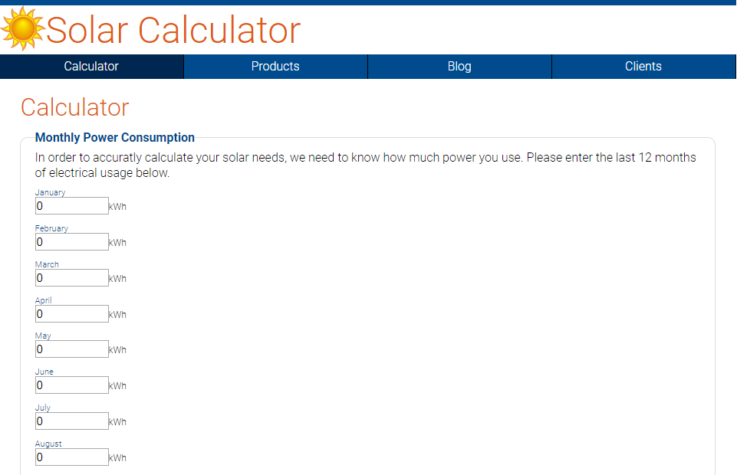

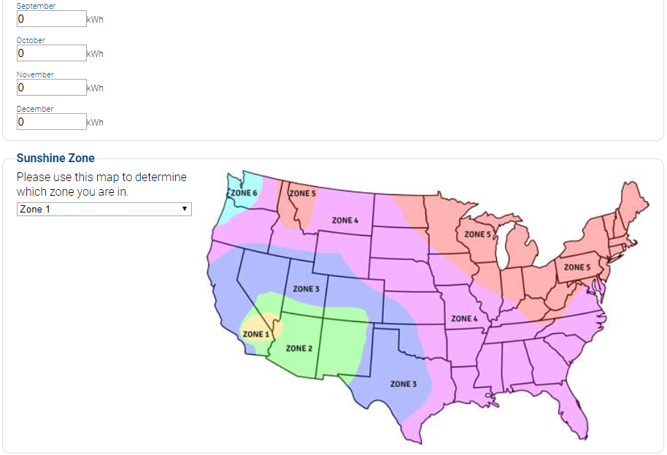

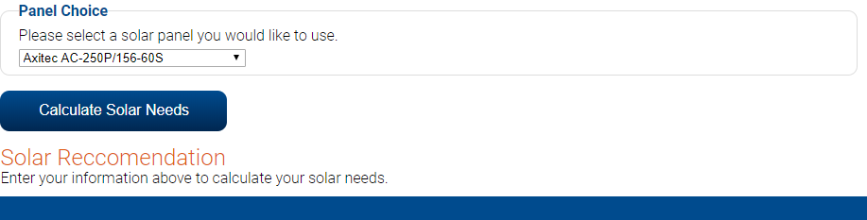

**HTML Code**

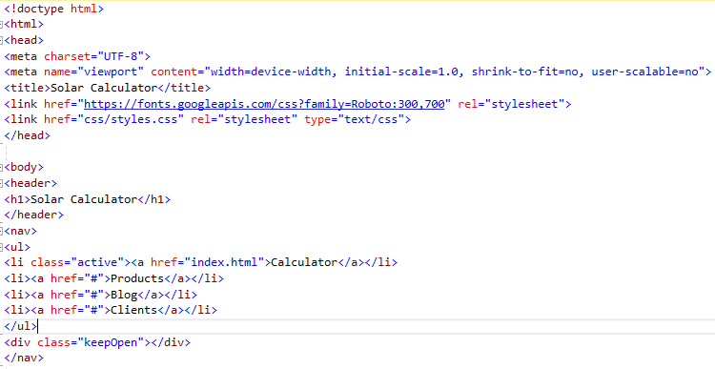

Display power usage of 12 months

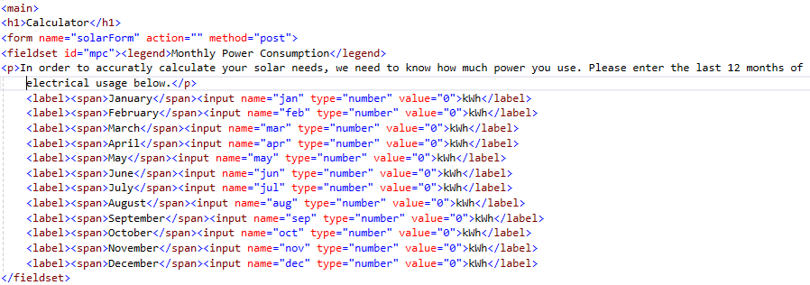

Display the Sunshine Zone in US.

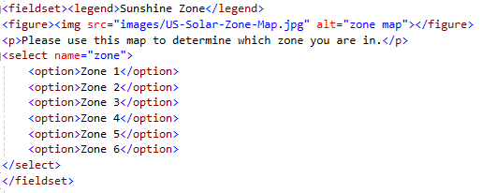

Display the Brand Panel Choice and value which in Watts per hour.

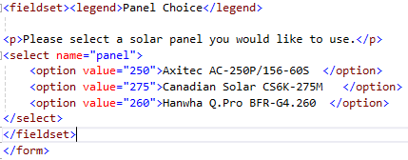

Displays the information by clicking on Calculate Solar Needs.

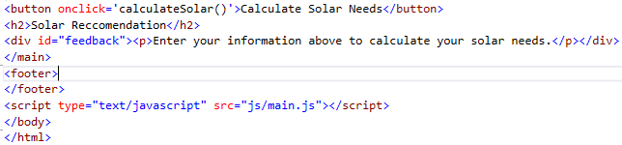

Here you have done the designing the web page. Now let’s check how the calculation will be done behind the web page.

**JavaScript Code:**

In the below code you can see there are four variables created, which are dailyUseKw, annulUseKw is Daily / Annually usage Kilowatt.

The for loop will display the annual usage of electricity by adding all the months, given by user.

To know daily usage of electricity, divide annualUseKw by 365.

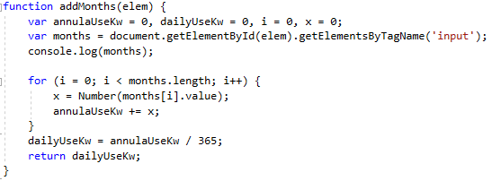

The theZone variable is referencing selected index (Note: from an array it will start 0). If we choose Zone 1 but don’t want return 0. So, we set theZone += 1. Now if they choose Zone 1, the value of Zone is 1 so we have even match.

The Switch case will be to set the values for hours of Sunshine on different Zone’s.

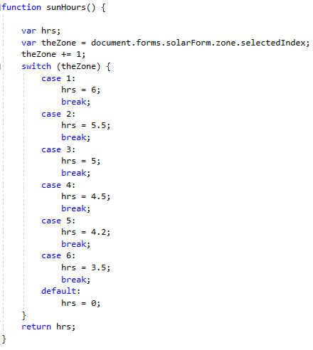

userChoice will get the selected index from panel in HTML.

panelOptions will get the name of the panel.

Power variable will pull out the value of correct one.

Variable x will get power generated per hour and name of the panel.

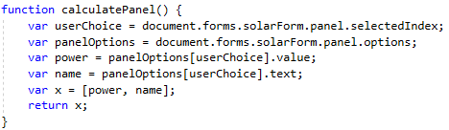

We know how much daily usage of Kw per day (i.e. dailyUseKw) and Sunshine hours per day (i.e. sunHoursPerDay). Now we need to calculate the minimum usage of Kw (i.e. minKwNeeds), dailyUseKw divided by sunHoursPerDay.

If there any bad weather, realKwNeeds is increased by 25% i.e. 1.25 multiple by minKwNeeds.

In order to compare to home usage which is Kw to the panels which are in Watts. We need to multiple by 1000 to realKWNeeds.

panelInfo go to calculatePanel() function to calculate x which is an array.

panelOutput will get first element array of panelInfo[0].

penelName will get second element array of panelInfo[1].

panelsNeeded is to get the how much panel required for total home.

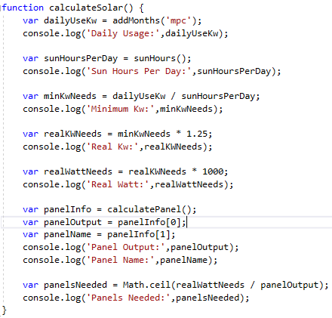

**Output: Right click on Calculate Solar Need, Inspect.**

